**About the Author**

Meet Shrihan, a 10-year-old young mind behind this extraordinary adventure! As a curious and enthusiastic young writer, he enjoys crafting exciting stories filled with brave heroes, fascinating discoveries, and unforgettable journeys that transport readers to amazing worlds beyond their wildest dreams.

"**Back and Forth: The Time Loop Trio**" marks his very first published book as a remarkable achievement that showcases his natural gift for storytelling and his passion for sparking wonder in young readers everywhere. A budding author with limitless potential, he hopes to inspire kids around the world to embrace their creativity, chase their biggest dreams fearlessly, and believe wholeheartedly in the magical power of their own imaginations. This is just the beginning of what promises to be an amazing literary journey!

**Introduction**

When nine-year-old Alex and his best friends Sid and Myra discover a glowing, jewel-covered time machine hidden in Grandpa's dusty old garage, their curiosity leads them on the wildest adventure of their lives! Despite a clear warning not to touch anything, one press of a button sends them hurtling through time—first to the terrifying age of dinosaurs where they befriend an adorable baby dinosaur named Luna and barely escape a hungry T-Rex, then accidentally into the dazzling future of flying cars and helpful robots. With danger at every turn and time running out, can the trio find their way back home safely? Perfect for readers aged 8-12, this thrilling time-travel adventure celebrates friendship, bravery, and the unforgettable magic that happens when ordinary kids experience extraordinary journeys together.

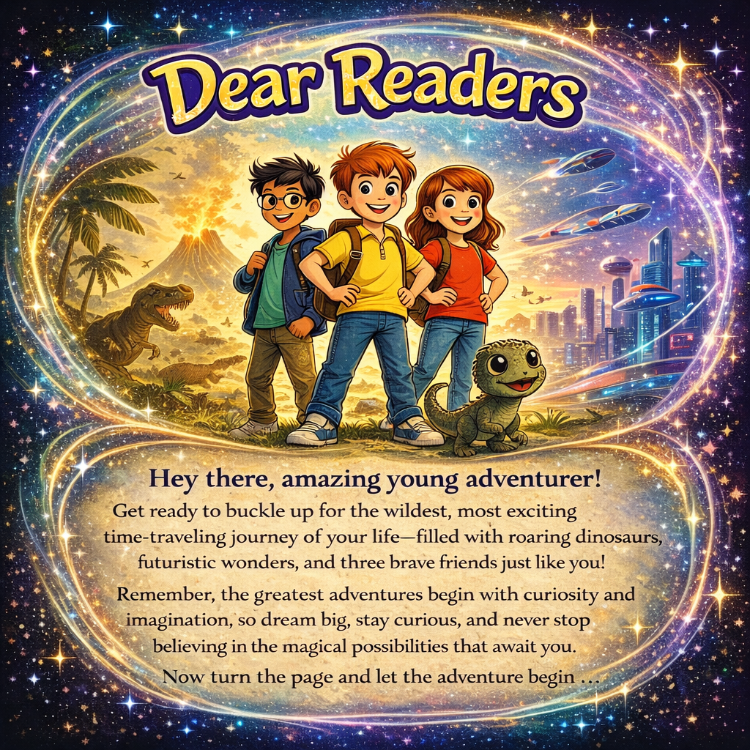

**Chapter 1**

**A Very Strange Discovery**

"Hi! I am Alex, and I am nine years old. I absolutely love jolly good adventure filled with thrilling excitement and mysterious surprises. Exploring fascinating new places and discovering wonderfully exciting things is what I enjoy the most. But nothing could possibly beat the extraordinary adventure that happened last Saturday; it was truly unforgettable and completely mind-blowing!

It all began while I was playing with my best friends, Sid and Myra, in my dear grandpa's enormous, dusty old garage. The massive space was crammed full of ancient treasures and forgotten relics from decades past. We were utterly bored and just carelessly poking around through weathered cardboard boxes and rusty metal crates. The musty air smelled of old motor oil and forgotten memories.

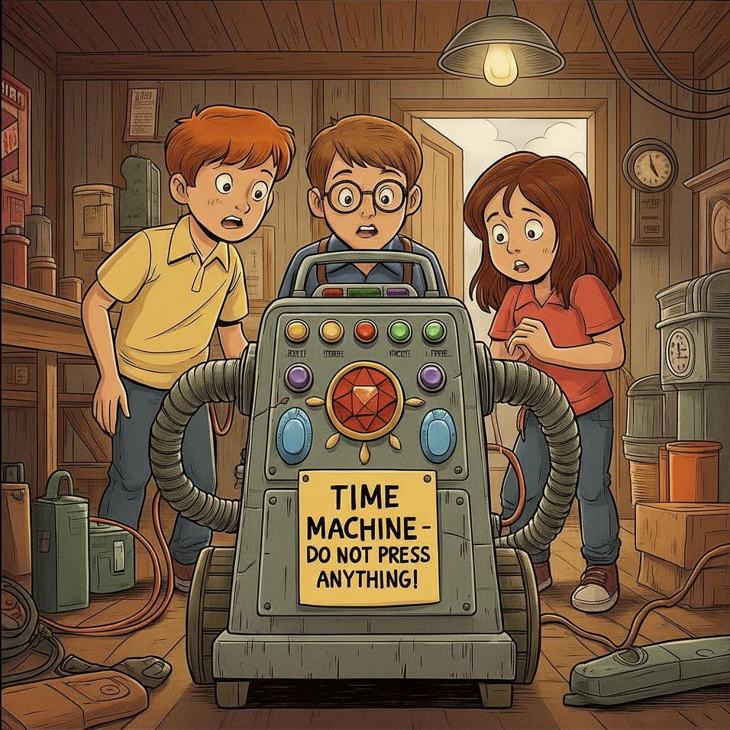

When suddenly, while squeezing behind a towering, precarious stack of grimy, cobweb-covered boxes, we noticed something peculiar and strange. It looked like an old vacuum cleaner at first glance, but it was definitely no ordinary household appliance. This mysterious contraption was far more magnificent and bizarre than any cleaning device we'd ever seen!

It had dozens of blinking, glowing buttons of every brilliant color of the rainbow—scarlet red, sunny yellow, emerald green, and electric purple all pulsing with an eerie, otherworldly light. There was a magnificent, blood-red ruby positioned perfectly in the gleaming center, as large as a robin's egg, and shimmering blue sapphires embedded on both sides, which sparkled and twinkled mesmerizingly under the dim, flickering garage light. The mysterious machine hummed with a soft, almost magical energy that made the fine hairs on my arms stand straight up.

There was also a crumpled, yellowed note stuck to its dusty side with ancient, brittle tape. It read in bold, urgent letters written in faded black ink:

**"TIME MACHINE – DO NOT PRESS ANYTHING!"**

We all froze completely, our hearts pounding wildly in our chests."

**Chapter 2**

**The Button We Shouldn't Have Pressed**

"What do we do now?" Sid asked nervously, his wide brown eyes shining with a mixture of fear and thrilling excitement. His voice came out as barely more than a shaky whisper.

"Let's press something!" Myra whispered excitedly, bouncing on her toes. Her curly black hair bobbed up and down as she leaned closer to the mysterious, glowing machine. "Come on! What's the worst that could happen?"

I hesitated for what felt like forever, my trembling hand hovering just inches above the colorful buttons. My brain screamed "DON'T DO IT!" but my curious heart pounded with wild anticipation. The magnificent ruby in the center seemed to pulse and glow brighter, almost like it was calling to us, begging to be touched.

But curiosity won the battle.

"Okay," I said, taking a deep, shaky breath. "Let's press the big red button—together. On the count of three. One... two... THREE!"

We pressed it firmly with our three pointer fingers all at once.

**ZOOOOOOOM!**

Brilliant, blinding lights flashed in every direction—red, blue, green, yellow—swirling around us like a crazy, spinning rainbow tornado! The incredible machine buzzed and hummed so loudly that the entire garage shook and rattled. Old tools hanging on the walls clanged together. Dust flew everywhere in thick, swirling clouds.

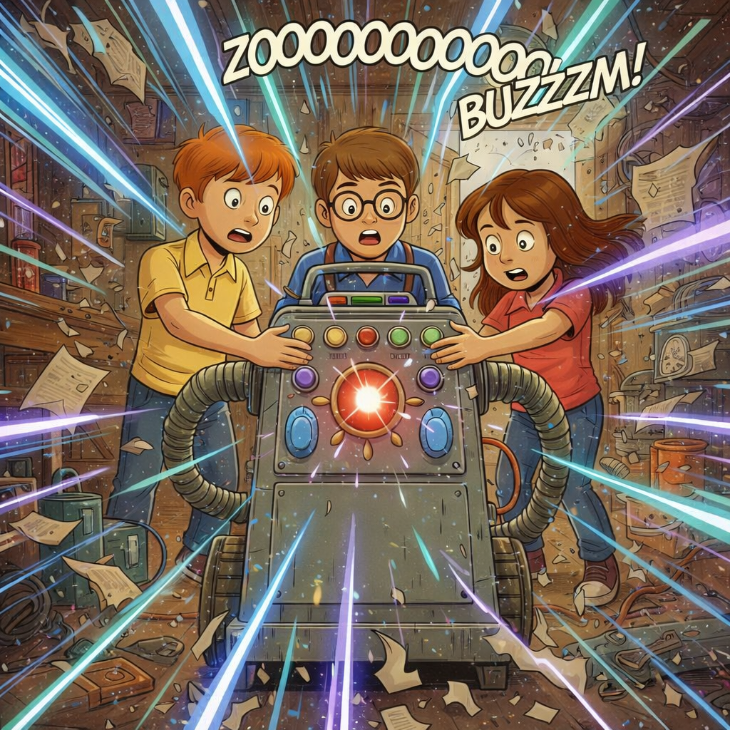

Everything spun wildly, faster and faster, like we were trapped inside a gigantic, out-of-control washing machine on the fastest spin cycle ever! My stomach did somersaults. My head felt dizzy and light. The whole world became a blurry mess of spinning colors and loud, whooshing sounds.

Then suddenly, everything went quiet.

A calm, smooth robotic voice—kind of like the voice on my mom's GPS—spoke from somewhere inside the gleaming machine. "Greetings, time travelers. Where would you like to go? Please state your destination clearly."

Our hearts racing wildly, without even thinking about the consequences, we shouted together in one excited, loud voice: "THE DINOSAUR ERA!"

The machine beeped three times.

**BEEP. BEEP. BEEP.**

"Destination confirmed," the robotic voice announced. "Preparing for time travel to the Mesozoic Era. Please hold on tight. Departure in five... four... three... two... one..."

**WHOOOOOOOOSH!**

**Chapter 3:**

**Welcome to Dinosaur Land**

**THUMP!**

The amazing time machine landed with a heavy, jarring bump that made our teeth rattle. For a moment, everything was perfectly still and silent. Then, slowly, a door we hadn't even noticed before hissed open with a soft *whoooosh* sound.

Brilliant, golden sunlight poured in through the opening like liquid honey, flooding the inside of the machine with warm, dazzling light. We had to squint and shield our eyes from the sudden brightness.

"WOW!" we all gasped together, our mouths hanging wide open in absolute amazement.

We stumbled out onto soft, spongy ground covered with thick, emerald-green moss and strange-looking ferns as tall as basketball hoops. Towering above us were enormous, ancient trees unlike anything we'd ever seen before—their massive trunks were as wide as school buses, and their leafy branches stretched impossibly high into the clear, bright blue sky. Some had giant leaves bigger than beach umbrellas!

The prehistoric air smelled absolutely wild and wonderfully fresh—like a mixture of wet earth after rain, sweet tropical flowers, and something mysterious we couldn't quite name. It was warm and humid, making our skin feel sticky and damp.

Strange bird-like calls echoed in the distance. Colorful insects the size of our hands buzzed past our heads with iridescent, shimmering wings.

And then we saw it—**A REAL, LIVING, BREATHING DINOSAUR!**

Our hearts nearly stopped!

A gigantic, magnificent brachiosaurus stood just a short distance away, peacefully munching on tender green leaves from the very top of an incredibly tall tree. Its long, graceful neck stretched up and up and up. It must have been as tall as a four-story building! Its enormous body was covered in thick, leathery skin that looked gray-green in the sunlight, with darker spots like a giraffe. Each of its massive legs was like a living tree trunk.

"I can't believe this is real!" I whispered, afraid my voice might scare it away.

Then, to our complete amazement, a small herd of majestic triceratops marched past in a slow, dignified line, like royal guards in a parade. Their magnificent three-horned heads were held high and proud. Their enormous bony frills—decorated with beautiful patterns of brown and orange—caught the sunlight and gleamed impressively. Their heavy footsteps made the ground tremble and shake beneath our sneakers. **THUD. THUD. THUD.**

We stood completely frozen, barely daring to breathe, watching the incredible parade of prehistoric giants.

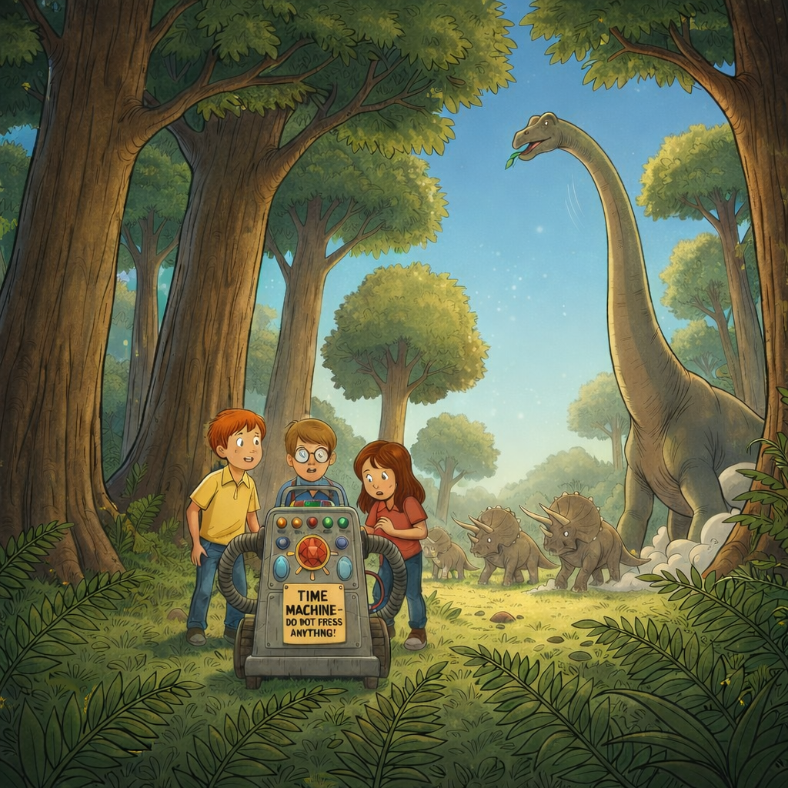

Just then, something rustled and shook in the thick, leafy bushes right behind us. We spun around quickly, our hearts pounding with nervous excitement.

Out stepped a small, adorable dinosaur—about the size of a golden retriever puppy. She had smooth, yellowish-tan skin with cute darker stripes running down her back. Her big, round eyes were deep brown and sparkled with friendly curiosity. A short, stubby tail wagged back and forth excitedly. She tilted her little head to one side and made a soft, chirping sound: "*Chirp-chirp!*"

"She's not scary at all!" Myra squealed with delight, immediately kneeling down. "She's absolutely adorable! Like a scaly puppy!"

The little dinosaur cautiously stepped closer, sniffing the air with her tiny nostrils. Then she gently nuzzled Myra's outstretched hand with her warm, smooth snout.

Sid smiled his biggest, brightest smile. "Let's name her Luna—because her color reminds me of moonlight!"

"Perfect!" we agreed enthusiastically.

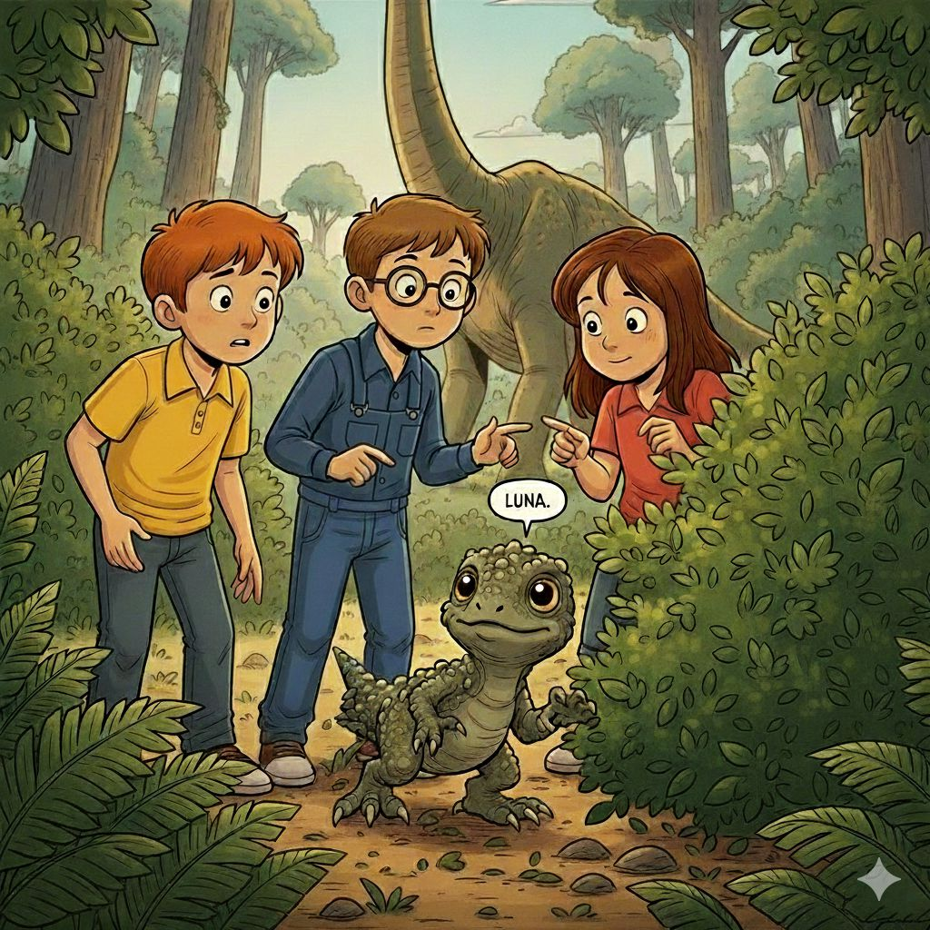

From that special moment on, Luna followed us everywhere we went—trotting along behind us just like a loyal, playful puppy! Her little clawed feet made soft *pat-pat-pat* sounds on the mossy ground. Whenever we stopped, she would chirp happily and rub against our legs, her tail wagging with pure joy.

We had made our very first dinosaur friend!

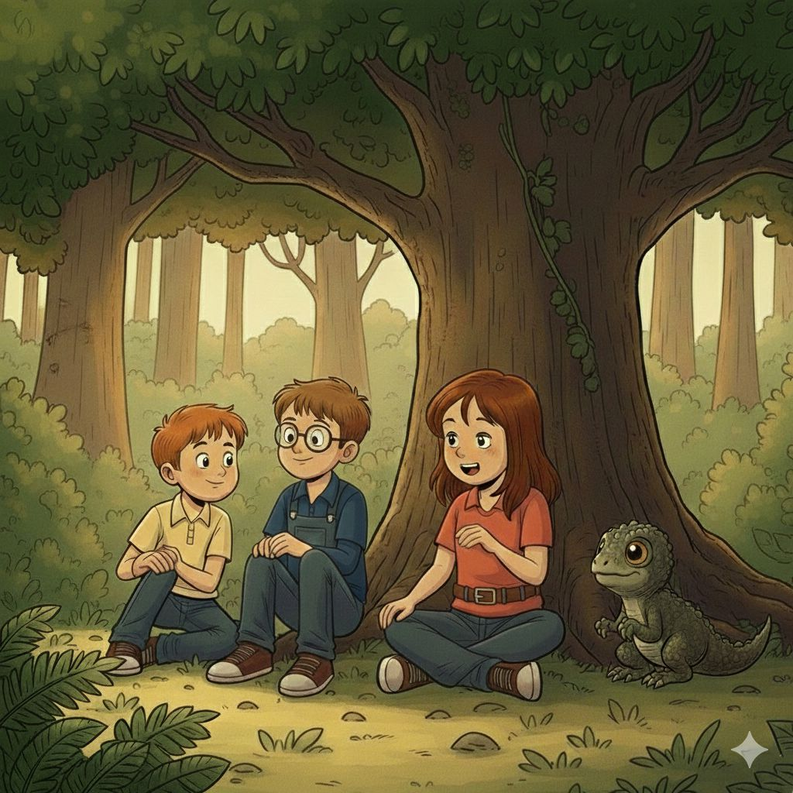

**Chapter 4**

**Trouble in the Jungle**

Everything was perfect and peaceful in the prehistoric paradise—until disaster struck!

Suddenly, Luna spotted a beautiful, enormous butterfly with shimmering purple and orange wings fluttering lazily past her nose. Her big brown eyes grew even wider with fascination. Without warning, our adorable little dinosaur friend took off in an excited chase, her stubby legs pumping as fast as they could go.

"Luna, wait!" I called out, but she was too focused on the dancing butterfly.

Luna darted this way and that, following the colorful insect's zigzagging flight path through the ancient ferns. Then, in her enthusiastic pursuit, she accidentally stepped directly onto the precious time machine with her surprisingly heavy little foot.

**BEEP!**

A sharp, alarming sound pierced the air.

All the beautiful, colorful lights that had been blinking and glowing on the magnificent machine suddenly flickered once, twice, and then went completely dark and dead. The soft humming noise stopped abruptly. The glowing ruby in the center faded to a dull, lifeless red.

Complete silence.

"Oh no! NO, NO, NO!" I shouted, my voice cracking with panic.

"We're stuck!" Myra cried out desperately, her face turning pale white with fear. "We're trapped in the dinosaur era forever!" Tears began welling up in her frightened eyes.

My hands shook as I frantically pushed different buttons, trying desperately to make something—anything—happen. Nothing worked. The machine sat there like a useless hunk of dead metal.

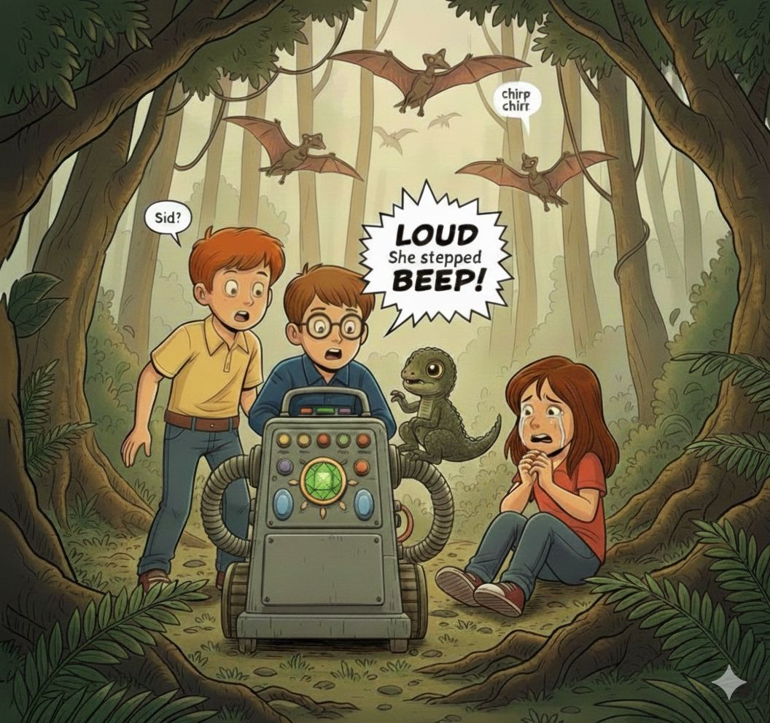

Before we could even begin to figure out how to fix the broken machine—

**ROAAAAAR!**

A bone-chilling, thunderous roar exploded from somewhere deep in the dense jungle behind us. The terrifying sound was so loud and powerful that it rattled our chests and made the very ground beneath our feet vibrate violently. Birds shrieked and scattered from the towering treetops in a panicked frenzy. Even Luna whimpered and pressed herself against my legs, trembling.

Then we heard it—the unmistakable sound of massive, heavy footsteps getting closer and closer.

**THOOM. THOOM. THOOM.**

A gigantic, fearsome Tyrannosaurus Rex burst through the thick wall of ancient trees like they were made of paper! Enormous branches snapped and crashed to the ground. The monstrous creature was absolutely terrifying—easily three times taller than a city bus, with huge, powerful legs covered in dark green, scaly skin. Its massive head was filled with rows upon rows of razor-sharp teeth, each one as long as a banana. Drool dripped from its gigantic jaws. Its fierce yellow eyes locked onto us like we were its next meal.

"RUN!" I shouted at the top of my lungs, my voice high-pitched with pure terror. "RUN FOR YOUR LIVES!"

We scrambled and stumbled over roots and rocks, our hearts hammering wildly in our chests like drums. Luna raced alongside us, chirping frantically. The monstrous T-Rex stomped after us with earth-shaking steps, getting dangerously closer with each thunderous stride.

**THOOM. THOOM. THOOM.**

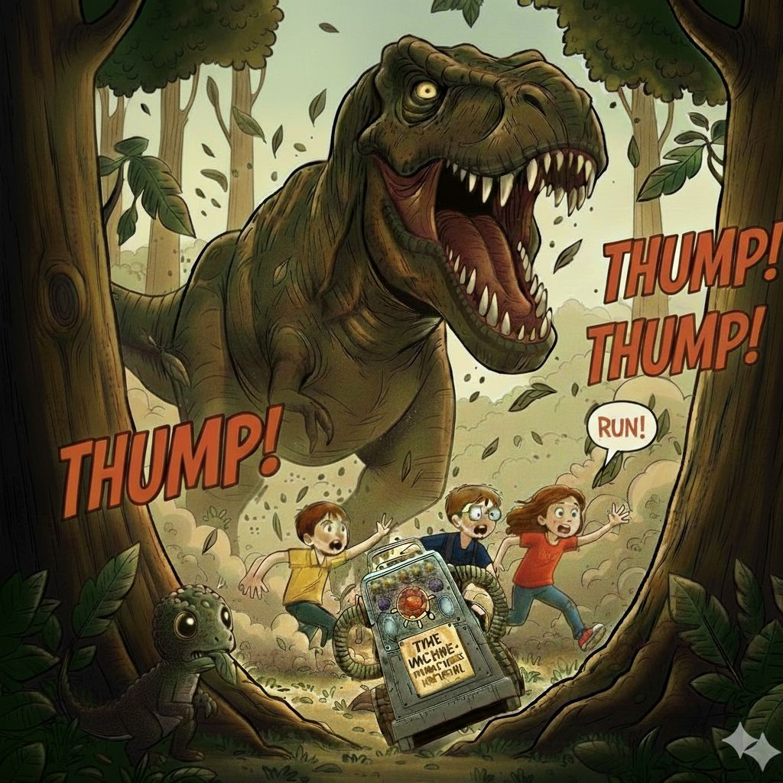

"We're not going to make it!" Sid screamed, his face red and sweaty.

We circled back desperately toward the lifeless time machine, knowing we had nowhere else to go. The terrifying T-Rex was now so close we could smell its horrible, rotten breath and hear its deep, rumbling growls.

Just as the massive dinosaur lowered its enormous head, opening its deadly jaws wide to snap us up—

**BEEP!**

A single, small green light suddenly blinked weakly on the control panel! Then another! And another!

"IT'S WORKING!" Sid yelled with desperate hope, his voice cracking. "THE MACHINE IS TURNING BACK ON!"

The ruby in the center began to glow faintly, getting brighter by the second. The other colorful buttons started blinking frantically—red, blue, yellow, purple—all pulsing with renewed energy!

"EVERYBODY INSIDE! NOW!" I commanded.

We dove headfirst into the time machine in a tangled heap of arms and legs, with Luna scrambling in right behind us. The T-Rex's massive jaws snapped shut with a horrifying **CHOMP** just inches from where we'd been standing a split second earlier!

With shaking, sweaty fingers, I slammed my hand down hard on the big red HOME button.

**WHOOSH!**

Brilliant lights exploded around us in a blinding whirlwind of dazzling colors! The machine buzzed and hummed loudly, shaking violently. Through the rapidly closing door, I caught one last glimpse of the frustrated T-Rex roaring angrily, its huge head thrashing from side to side.

Everything spun faster and faster, the colors blurring together into a magnificent rainbow tunnel.

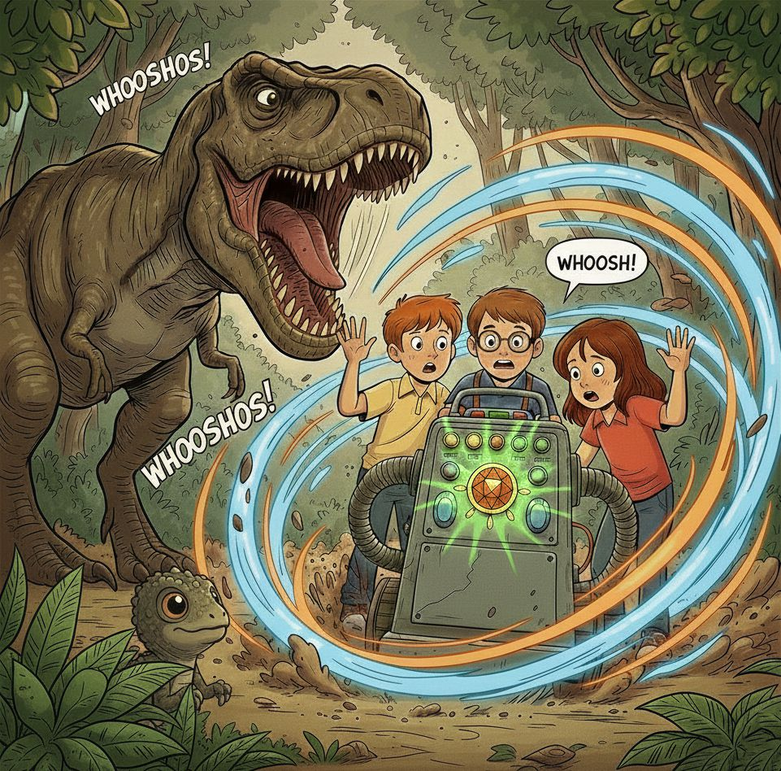

The T-Rex's mouth snapped shut behind us, missing us by inches.

My heart was still racing so fast I thought it might burst right out of my chest. Myra was breathing in quick, gasping gulps. Sid's hands were still trembling.

Through the window, I saw Luna peeking from her hiding spot. Her eyes were wide, but she looked relieved that we were safe.

“Bye Luna! Stay safe!” we shouted, as the door closed and the machine vanished in a spiral of time.

We were gone – saved by seconds and on our way home.

**Chapter 5**

**A Future Full of Wonders**

We thought we were going back home.

The time machine spun and spun – faster than ever before. We held on tightly and waited for the familiar feeling.

The wild spinning finally slowed down and then stopped completely. The brilliant, swirling lights faded away. The deafening whooshing noise became quiet.

**THUMP!**

The trusty time machine landed with another solid bump.

We took deep, relieved breaths, expecting to tumble out into the familiar, dusty comfort of Grandpa's old garage with its smell of motor oil and stacks of cardboard boxes.

But instead—

"WHOA!" we all screamed together as the door hissed open.

Our jaws dropped to the floor. Our eyes grew as wide as dinner plates.

Sleek, shiny flying cars zoomed past overhead in organized lanes of traffic, their smooth metallic bodies reflecting rainbow colors in the sunlight! Some were cherry red, others electric blue or gleaming silver. They made soft *whoooosh* sounds as they glided effortlessly through the crystal-clear air without a single honk or rumble. No wheels. No roads. Just pure, graceful flight!

Tall, helpful robots walked casually down spotless sidewalks alongside people, carrying colorful shopping bags and pushing floating strollers. The robots had smooth, white plastic bodies with glowing blue circles for eyes. They waved politely at each other and spoke in friendly, musical voices. Some were shaped like humans, while others looked like walking refrigerators with arms!

Towering all around us were the most incredible, magnificent glowing buildings we'd ever seen—enormous skyscrapers made entirely of shimmering glass that seemed to change colors like magic! One moment a building would glow soft pink like cotton candy, the next it would shift to peaceful ocean blue, then transform into vibrant emerald green. Holographic advertisements floated in mid-air, showing 3D images of smiling people and amazing products that looked like they came straight from a science fiction movie.

The streets were perfectly clean and covered with some kind of smooth, pearly white material that seemed to glow softly. Beautiful trees with strange purple and silver leaves lined the pristine walkways, and colorful flowers we'd never seen before bloomed in floating planters that hovered magically without any support!

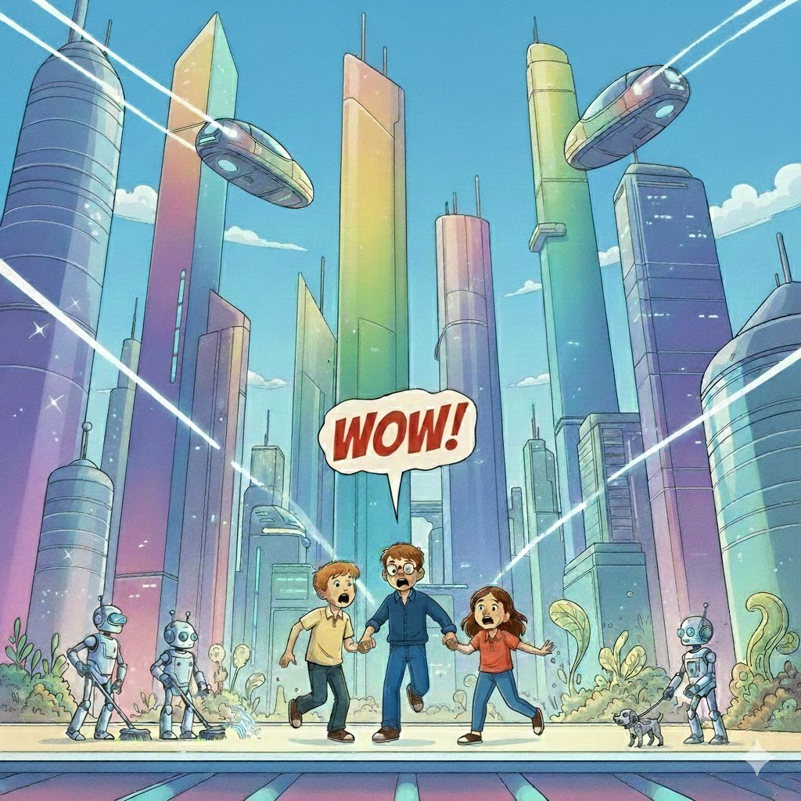

"Where... where ARE we?" Myra stammered, clutching my arm tightly.

Just then, a girl around our age glided towards us on the coolest futuristic bicycle we had ever seen. It actually had wheels, but they barely seemed to touch the ground as she soared through the air, lifted high above us. The bike was sleek and metallic, with thin spokes that shimmered as it moved.

Her brown hair streamed behind her, loose and flowing as she rode. She wore a white, form fitting suit with subtle futuristic details, and a compact backpack strapped to her shoulders. Leaning forward confidently, she gripped the handlebars with ease, her face calm and focused as she hovered effortlessly above the street.

“Uh...hi”, I said, my voice wobbling as I looked up at her hovering bicycle. “Can you tell me – um - what year this is?”

With perfect balance and control, the girl gently slowed in mid-air, the bike humming softly beneath her and floating as if gravity itself had decided to take a break. She tilted her head, her eyes narrowing in confusion.

“Year?” She repeated.

My stomach dropped. I swallowed hard and rushed to explain. “We’re not from here. My friends and I were in 2026, playing with my grandpa’s old time machine. We pressed the wrong button, and everything went wrong. Now we’re lost, and we don’t know how to get back.”

“Please help us,” Sid said, his voice full of worry.

“We’ve been trying to figure this out all by ourselves,” Myra added, blinking back tears.

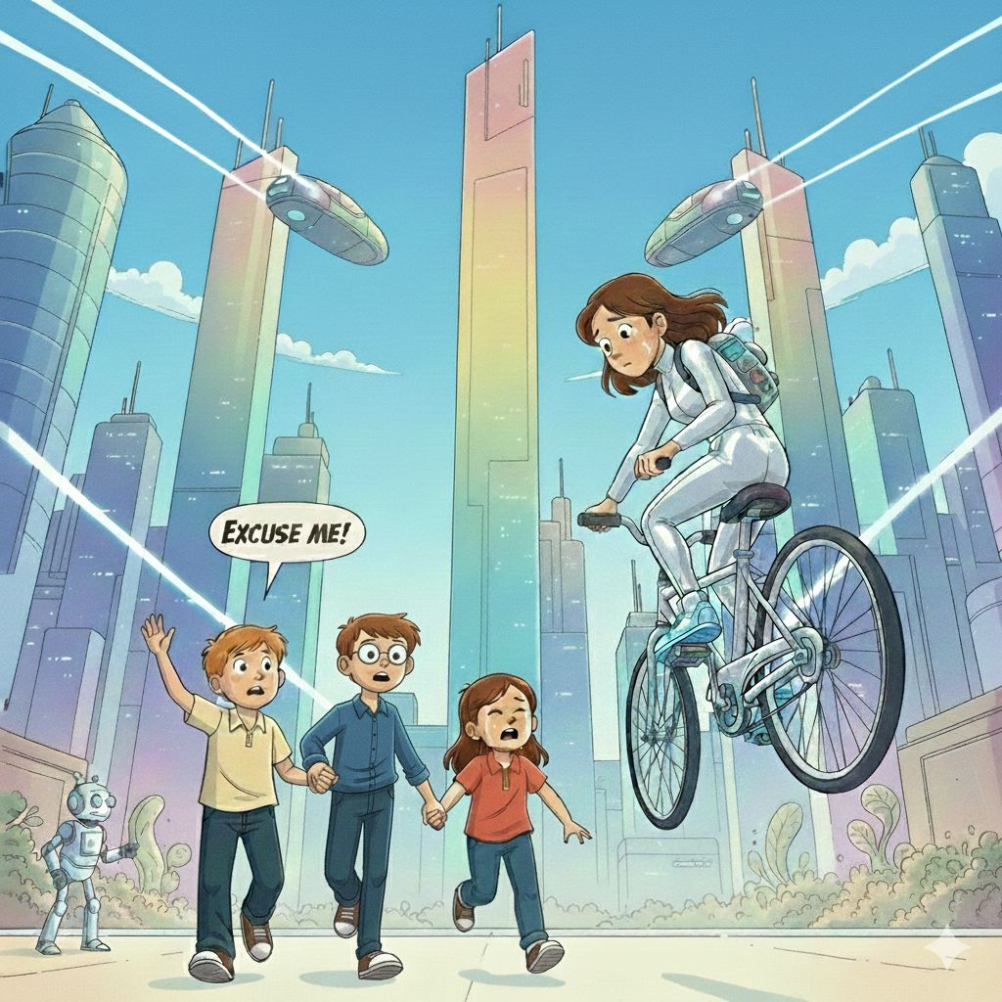

The girl studied us for a moment- our scared faces, our dusty shoes, the way we cling together. Then her expression softened, and a calm smile spread across her face.

"How totally awesome! I'm Zara Chen," she said cheerfully, extending her hand for a handshake.

She paused, as if checking something in her mind, then spoke again - slowly and clearly.

"Welcome! You're in New Metro City, and this is the year 2226. You've traveled exactly one hundred years into the future!"

"2226?!" Sid's mouth fell open so wide a tennis ball could have fit inside. "We've gone TOO far!"

The words echoed in my head. Two hundred years. I looked up at the towering glass buildings, the glowing paths beneath our feet, and the silent machines drifting through the sky. Suddenly, everything made sense – and felt even more unbelievable.

Zara's smile faded when she noticed our worried, panicked expressions. She nodded. “I know this is a lot to take in,” she said kindly. “Anyone would be scared in your place. But you’re safe now.”

She leaned closer on her bike and lowered her voice, as if sharing a secret.

“My father is a scientist,” she said. “He's Dr. Marcus Rayden—one of the world's leading scientists who specializes in time travel technology and quantum physics. If there’s a way to fix this, he’ll know how.”

A warm feeling spread through my chest. For the first time since we landed in this strange future, I felt something other than fear.

HOPE.

Zara smiled and tapped a glowing blue button on the side of her bicycle.

With a soft whirr and a shimmer of light, the bicycle began to change. The frame stretched and widened, the seat sliding back as if it were alive. In seconds, it transformed into a larger, sleeker ride—perfectly shaped to fit all four of us. Even our bulky time machine shifted neatly into a secure space behind us, locking in place with a gentle click.

“Hop on!” Zara said cheerfully.

Still a little nervous, we carefully climbed aboard, holding on tight. The moment everyone was settled, the bicycle hummed again and slowly lifted off the ground, rising higher and higher until the street below shrank into a glowing ribbon of light.

Then—whoosh!

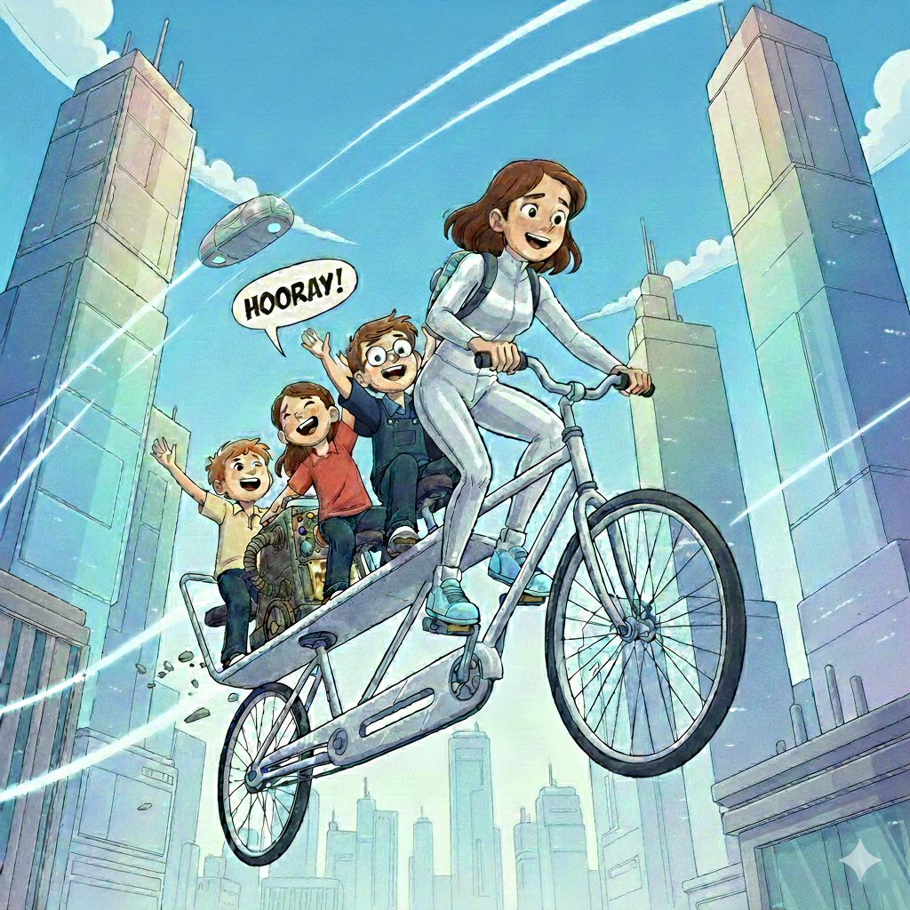

We soared forward, weaving smoothly between tall glass buildings and zooming past sky-buses that floated along glowing lanes in the air. The ride was so steady and gentle, it felt less like flying and more like gliding on clouds.

Below us, the future unfolded like a dream. Floating parks drifted between buildings, their trees swaying softly in the breeze. Kids bounced and laughed while playing hover-ball, leaping impossibly high. Sleek sky-trains zipped silently along transparent tracks, flashing by in streaks of light.

Neon colors shimmered everywhere, reflecting off windows and pathways. The air felt cool and fresh, carrying a clean scent—almost like flowers mixed with mint.

“This place is amazing,” Myra whispered, her earlier tears completely forgotten.

Sid leaned forward and pointed excitedly. “Look! That robot is walking a cat!”

We laughed, our fear melting away as we took in every incredible sight. For the first time since our accidental jump through time, our hearts felt light.

We were flying toward hope—toward help—and maybe… just maybe… toward home.

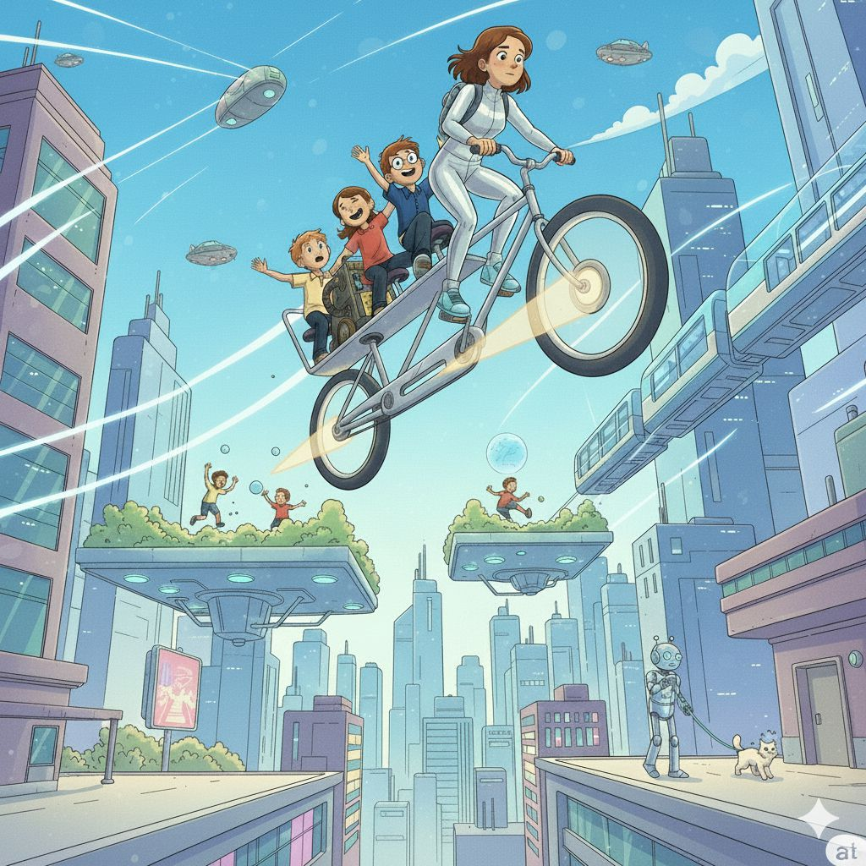

So caught up in the wonder below, we didn’t even notice when the buildings began to thin and the lights softened.

“Here we are!” Zara said as the bicycle slowed and gently hovered in place.

We looked ahead, knowing the next part of our adventure was about to begin.

Her home looked like a giant glass bubble floating in the sky, shimmering against the clouds. Silver vines curled gracefully around the outside, slowly shifting as if they were alive. Along the sides, solar panels shaped like delicate butterfly wings caught the sunlight, opening and closing gently as they absorbed energy. The smooth glass walls changed colors every few seconds—blue, then gold, then green, then purple—casting a magical glow across everything around it.

Zara’s bicycle slowed and gently landed on a hovering platform just outside the house. With a soft whoosh, the doors of the bubble slid open, welcoming us inside.

“Come in,” Zara said, stepping forward confidently.

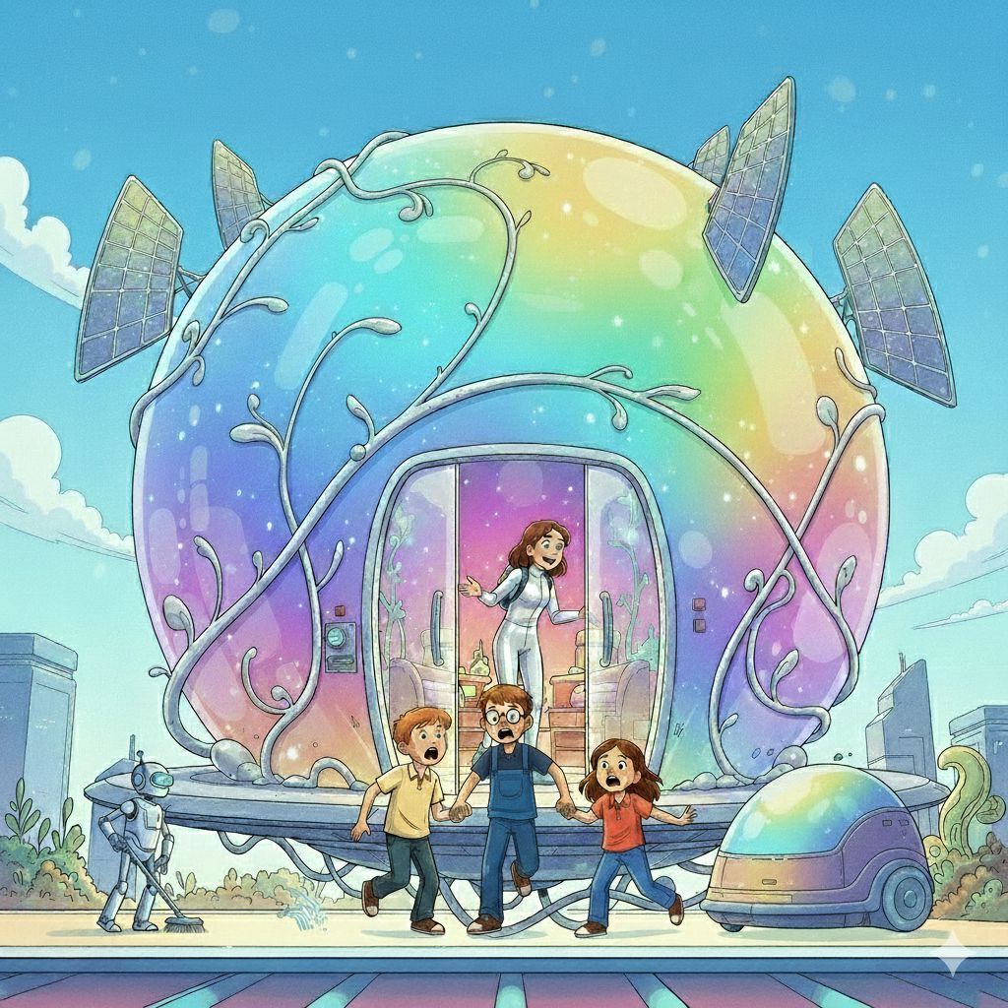

The moment we entered, it felt like we had walked straight into a dream.

A cheerful, friendly voice echoed around us.

“Welcome home, Zara. Visitors detected. Should I make hot chocolate?”

We looked around in surprise. The voice seemed to come from everywhere at once—it was her smart home system, built right into the glowing walls.

“Yes, please,” Zara replied with a smile. “They’ve had a long day.”

“You guys must be tired.”

As soon as we stepped farther inside, we slipped off our shoes. Almost instantly, small robot slippers zoomed across the floor, stopping neatly in front of each of us. Before we could react, they slid onto our feet all by themselves, warm and perfectly snug.

The floor beneath us felt soft and springy, like walking on clouds, and it glowed gently with every step we took. Around us, furniture floated calmly in mid-air—plush cushions, sleek chairs, and even a tall bookshelf that slowly rotated like a carousel, letting books drift past one by one.

Soft music flowed from the walls, calm and soothing, while tiny lights blinked and twinkled above us like stars in a night sky.

“Make yourselves comfortable!” Zara said, leading us toward a floating dining pod that drifted closer as we approached.

“This is the coolest house EVER,” Sid exclaimed, spinning happily in a chair that hovered a few feet off the ground.

Suddenly, another friendly voice chimed in from the ceiling.

“Would you like snacks, meals, or surprises?”

My eyes widened with excitement.

“Surprises, please!” I said quickly.

The room seemed to hum with anticipation.

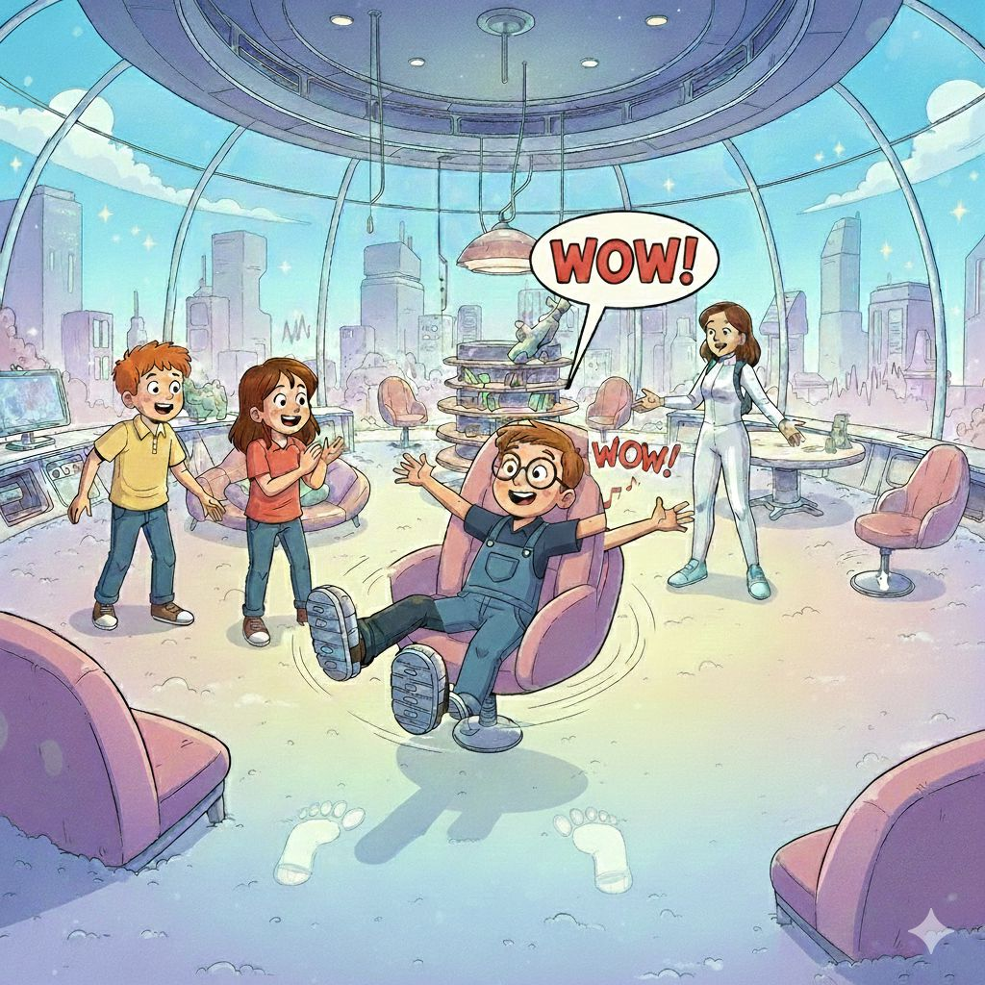

The center of the table suddenly split open with a soft whirr, and tiny silver food domes slowly rose up, one by one, as if lifted by invisible hands. They shimmered under the glowing lights, opening gently to reveal the most unbelievable food we had ever seen.

Inside were treats that looked like they belonged in a dream.

There were mini rainbow pizzas, their crusts glowing softly. The moment you took a bite, the flavor changed—first gooey cheese, then sweet strawberry, then a surprising burst of bubblegum. Every bite was a new adventure.

Next to them sat glowing donuts, floating slightly above their plates. Their colorful sprinkles danced, popped, and crackled like tiny fireworks, filling the air with happy little sparks of light.

A tall glass held floating juice balls, each clear bubble wobbling gently inside. Every bubble hid a different flavor. You had to pop them in your mouth to discover whether you’d get orange, mango… or—if you weren’t lucky—broccoli!

Myra giggled as her drink bubbled and slowly turned bright purple right before her eyes.

Sid grabbed a shiny silver chip and crunched down. His eyes went wide as it instantly melted, then poof!—turned into warm, fluffy popcorn right inside his mouth.

I scooped up a spoonful of something labeled “Frosty Cloud Cream.” It looked like cotton candy but felt icy and fizzy the moment it touched my tongue, tingling and sparkling like a winter breeze.

Zara watched us with an amused smile.

“Pretty cool, right?”

“Cool?” Sid said, grinning from ear to ear. “This is like eating a science experiment!”

We burst out laughing and kept tasting everything, amazed with every bite. Soon our bellies felt full and warm, and the tight knot of fear we’d been carrying all day finally loosened.

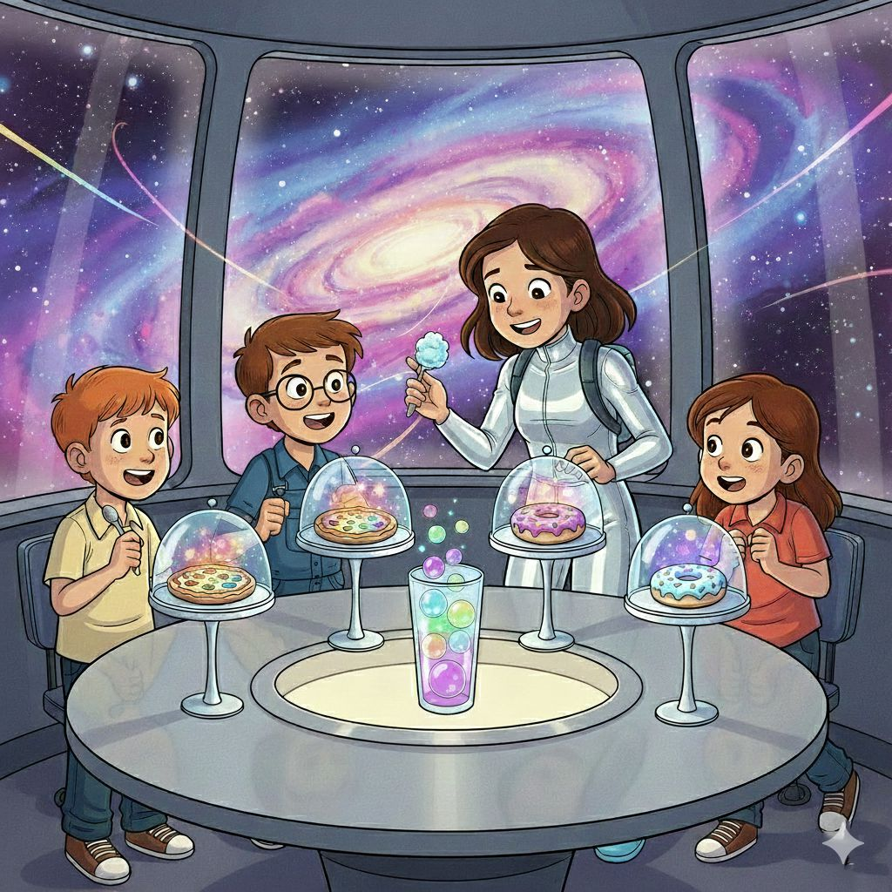

For the first time since we’d been thrown into the future, we felt calm… safe… and maybe—even ready for whatever came next on our journey.

A moment later, someone stepped into the room, a tall, kind-looking man with neat gray hair, warm brown eyes behind sleek digital glasses that glowed faintly at the edges as data scrolled across the lenses, and a bright white lab coat covered with colorful patches and scientific badges. His friendly face lit up with genuine excitement when he saw our battered, old-fashioned time machine. His calm presence filled the space instantly

“Dad,” Zara said proudly, turning toward him, “meet my new friends. They’re from the year 2026.”

He paused, raising one eyebrow in surprise—but instead of alarm, a warm smile spread across his face.

“Ah,” he said with a gentle chuckle, “time travelers! You don’t see those every day.”

He extended a hand. “I’m Dr. Rayden, Zara’s father—and a time-tech scientist.”

We took turns explaining everything—the cluttered garage at Grandpa’s house, the strange vacuum-cleaner-shaped machine, our accidental jump to the Dinosaur Era, Luna the friendly dino, and finally how one wrong button press had landed us here in the year 2226.

Dr. Rayden listened closely the entire time, nodding thoughtfully and occasionally adjusting his glowing glasses. When we finished, he folded his arms and let out a soft hum.

"Fascinating! Absolutely fascinating!" he exclaimed, walking around our machine slowly, examining every detail with wide-eyed wonder. "This is primitive temporal technology—probably from the early 2000s! It's a miracle you made it here safely at all! These old models were notoriously unstable and unpredictable."

My heart sank—until he continued.

He pulled out a glowing holographic tablet from thin air and began scanning our damaged machine with beams of soft blue light.

"The temporal navigation system is completely fried," he explained, pointing to the dark, lifeless buttons. "And your quantum stabilizer is cracked—see this hairline fracture? That's probably why you overshot your intended destination by centuries!"

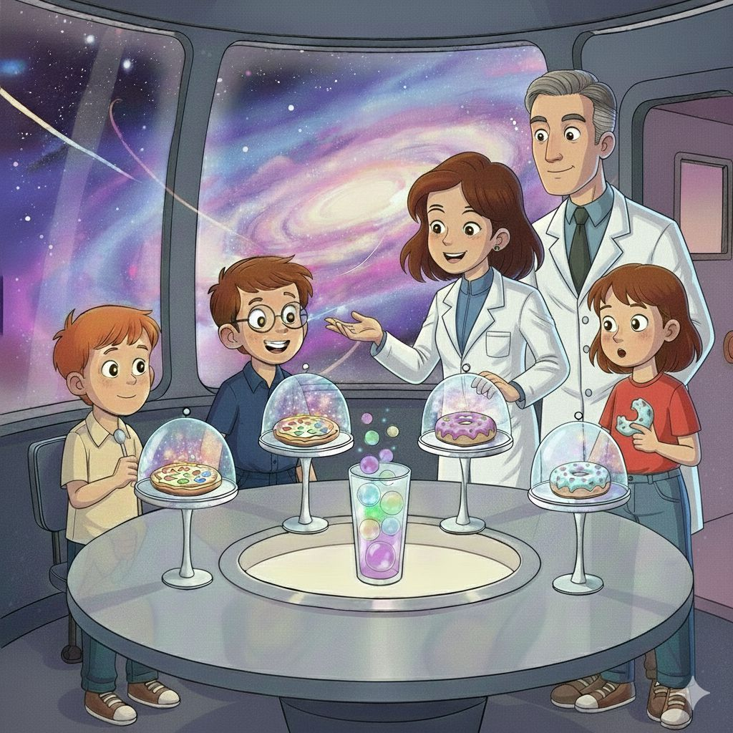

"Can you fix it?" Myra asked desperately, her voice small and worried. "We just want to go home to our own time."

Dr. Rayden's kind face broke into a reassuring, confident smile. "Of course I can fix it! I've been studying and repairing time machines for over thirty years. This wonderful device just needs some modern upgrades, a new power crystal, and proper temporal calibration." He patted the machine gently, like it was an old, beloved car.

“Really?” I asked, my eyes widening. “You can fix it?”

“With some help,” he replied, tapping the sleek smartwatch on his wrist.

Instantly, panels in the walls slid open, and tiny robots rolled out onto the floor. They had glowing eyes, spinning tools, and thin metal arms that moved like spider legs as they scurried into place. Incredible futuristic tools that floated in the air and glowing instruments that made soft beeping sounds.

“I’ll need about an hour,” Dr. Rayden said. “Make yourselves comfortable.”

So we waited—sipping hot chocolate that stirred itself automatically and never cooled, and laughing as Zara showed us her hologram pet: a glowing blue fox named Pixel, who leaped through the air and wagged its shimmering tail.

For the first time since our time-travel disaster began, the future didn’t feel so scary.

It felt like help had finally arrived.

Finally, Dr. Rayden returned, his face glowing with a big, confident smile that instantly filled the room with hope. Behind him, the last of the holographic tools folded themselves neatly back into the walls, disappearing as smoothly as they had appeared. The tiny repair robots chirped softly and scurried away, their metal legs clicking as the lab returned to calm.

"All done! Your machine is not only repaired—it's better than new! I've programmed the exact coordinates to return you safely to your own time period."

For a heartbeat, none of us moved. We just stared at him, letting the words sink in.

Then—

“Yes!” we shouted all at once.

We jumped up, laughing and hugging each other tightly, spinning in happy circles. All the fear, confusion, and worry we’d been carrying melted away, replaced by pure relief and excitement.

“Thank you SO much!” we said together, our voices full of gratitude.

Dr. Rayden placed a gentle, fatherly hand on my shoulder and looked at each of us seriously. "Now listen carefully. When you get home, I want you to promise me something very important. Hide this time machine somewhere extremely safe where nobody else will ever find it. Time travel is wonderfully exciting, but it's also incredibly dangerous. Promise me?"

We all nodded solemnly, understanding the heavy weight of his words.

"We promise," we said together in one unified voice.

Dr. Rayden smiled warmly and gave us each a quick, caring hug. Zara waved enthusiastically, already programming our home coordinates into the newly fixed control panel.

Zara stepped forward, her eyes bright as she smiled at us. "Safe travels, time travelers! Maybe we'll meet again someday!", she said warmly, giving a playful wave, “just maybe not by accident next time!”

Nearby, the time machine waited patiently. It looked completely different now—sleek and polished, with new shimmering panels along its sides. Soft lines of light pulsed gently, and tiny indicators blinked in steady, confident patterns. It no longer felt unpredictable or dangerous.

It felt ready.

We climbed inside carefully, one by one, and settled into our seats. The door slid shut with a reassuring click.

Outside, Zara stood on her floating doorstep, waving enthusiastically. Beside her, Pixel—the glowing blue hologram fox—let out a tiny, cheerful howl, its sparkling tail bouncing as it leaped in place.

Dr. Rayden stepped back and gave us an encouraging thumbs up.

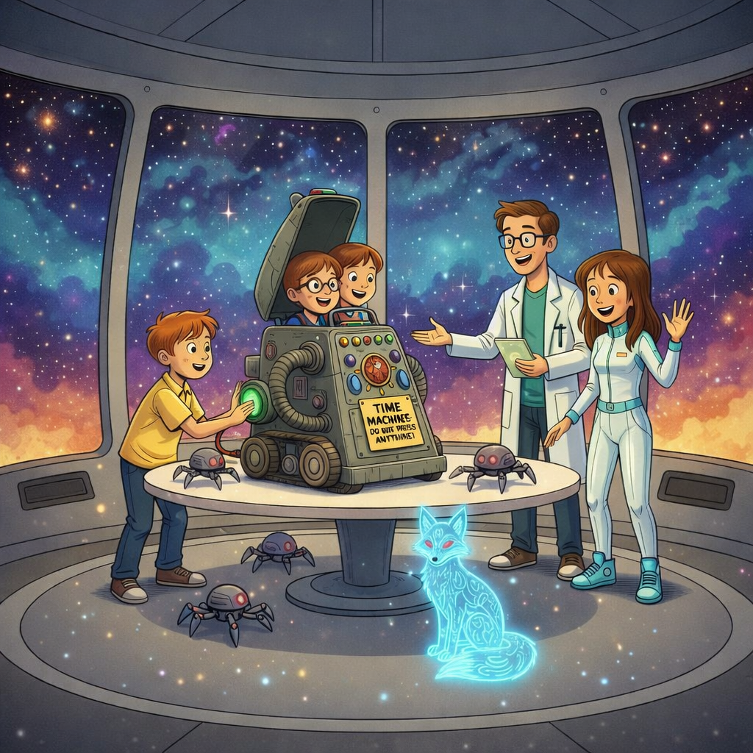

“Ready?” I asked, my hand hovering over the familiar green button as I looked at Sid and Myra.

“Ready!” they shouted together, grinning from ear to ear.

I took a deep breath and pressed the button.

WHOOSH!

The machine roared to life. The world twisted and spun around us, colors stretching into brilliant streaks of light as the air hummed with energy. My heart thumped wildly as we grabbed onto each other, holding tight inside the swirling glow.

But this time, there was no fear.

Only excitement.

Only hope.

This time… we knew we were going home.

**Chapter 6**

**Back Where We Belong**

Suddenly—**THUD!**

The time machine jerked hard, and everything froze.

The incredible time machine landed with one final, familiar bump that rattled our bones.

The blinking lights flickered wildly, then slowly dimmed. The whirling noise that had surrounded us faded into a soft hum… and then into silence. The air felt heavy, as if the whole world was holding its breath.

For a long moment, we sat perfectly still inside the quiet machine, hardly daring to breathe or move. Our hearts were pounding with nervous anticipation. Had it actually worked? Were we really home? Or had we landed somewhere else entirely—maybe ancient Egypt or the Wild West?

Slowly, cautiously, the door hissed open with a soft *whoooosh*.

Carefully, we leaned forward and peeked out of the door.

Sweet, familiar air rushed in.

My eyes adjusted to the dimmer light, and suddenly I could see them—same dusty wooden shelves stood exactly where they always had, stacked with jars! Old rusty tools hanging on faded pegboards!

Stacks of wrinkled cardboard boxes covered in thick cobwebs which grandpa never threw away!

The familiar creaky wooden stool, one leg still shorter than the others. The ancient workbench piled high with forgotten projects!

The same faded calendar from three years ago still hanging crooked on the wall. The smell of oil, metal, and old wood wrapped around us like a memory. Sunlight streamed in through the small window, painting golden squares on the floor—just the way it had earlier that day.

Grandpa's garage.

Beautiful, messy, wonderful Grandpa's garage!

My eyes darted to the wall clock.

**3:43 PM.**

The exact minute we had left.

It was as if time itself had politely waited for us to return.

For a moment, no one moved.

“Did it really happen?” I whispered, my voice shaky, as though I was afraid the answer might disappear.

Sid touched his face, then laughed softly. “It did,” he said. “I can still taste the hot chocolate… and the Frosty Cloud Cream.”

"We're home!" Myra screamed with pure joy, tears of relief streaming down her happy face. "WE'RE ACTUALLY HOME!"

We turned back to the time machine. It was still humming quietly, but it looked nothing like before. Smooth silver panels gleamed along its sides, glowing lines pulsed gently, and tiny lights blinked with confidence instead of chaos. Near the control panel, a small sticker caught our attention. It read:

**Property of Dr. Rayden, 2226**

"GRANDPA!" I shouted at the top of my lungs, bursting through the creaky garage door that led into the house. "GRANDPA! You absolutely won't believe what just happened to us!"

My dear grandpa looked up from his comfortable, worn armchair where he'd been peacefully reading the Sunday newspaper. His bushy gray eyebrows rose high on his wrinkled forehead with surprise. His kind blue eyes twinkled with curiosity behind his old-fashioned round glasses.

"What's all this commotion about?" he asked with a gentle, amused smile, carefully folding his newspaper and setting it aside on the small wooden table.

We all started talking at once, our words tumbling out in an excited, jumbled rush—talking over each other, interrupting, gesturing wildly with our arms.

"There was this machine—"

"—with glowing buttons and jewels—"

"—and we went back to dinosaur times—"

"—a HUGE T-Rex almost ate us—"

"—then we accidentally went to the future—"

"—flying cars and robots everywhere—"

Taking a deep, calming breath, I started again from the very beginning, telling the incredible story more slowly and carefully this time. Sid and Myra jumped in with important details I forgot. We described everything—the magnificent machine hidden behind the dusty boxes, the terrifying prehistoric jungle with towering ancient trees, our adorable dinosaur friend Luna, the bone-chilling T-Rex chase, the mind-blowing futuristic city, the kind scientist Dr. Rayden, and his brilliant daughter Zara with her amazing floating bicycle.

Grandpa listened quietly and patiently to our wild, unbelievable tale, his weathered face completely unreadable, nodding occasionally but saying nothing.

When we finally finished our breathless story, there was a long moment of thick silence.

Then Grandpa blinked once... twice... and suddenly burst out laughing! "Ha ha ha! Oh, my stars!" he chuckled, slapping his knee with delight. It was a deep, warm, belly-shaking laugh that made his whole body jiggle and his eyes crinkle up at the corners.

His laughter was so infectious that soon we were all giggling too, even though we didn't quite understand what was so funny.

He wiped tears of laughter from his twinkling eyes with a faded handkerchief he pulled from his shirt pocket.

"Well," he said finally, still chuckling and shaking his head in amazement, “Let's go into the garage again.”

The three of us looked at one another, our eyes wide with excitement and curiosity. We had just been sitting together, talking nonstop. Even now, it felt unreal, like the adventure was still buzzing quietly in the air around us.

Without another word, we followed Grandpa toward the garage, our footsteps quick and our hearts beating a little faster with each step. Even though our journey through time was over, a strange feeling tugged at us, like the story wasn’t quite finished yet.

“I suppose I built a whole lot more than just a fancy vacuum cleaner after all, didn’t I?” Grandpa said, pausing near the old workbench and resting his hand on its worn wooden surface. His smile was full of pride, but there was something else there too—something knowing, something mysterious.

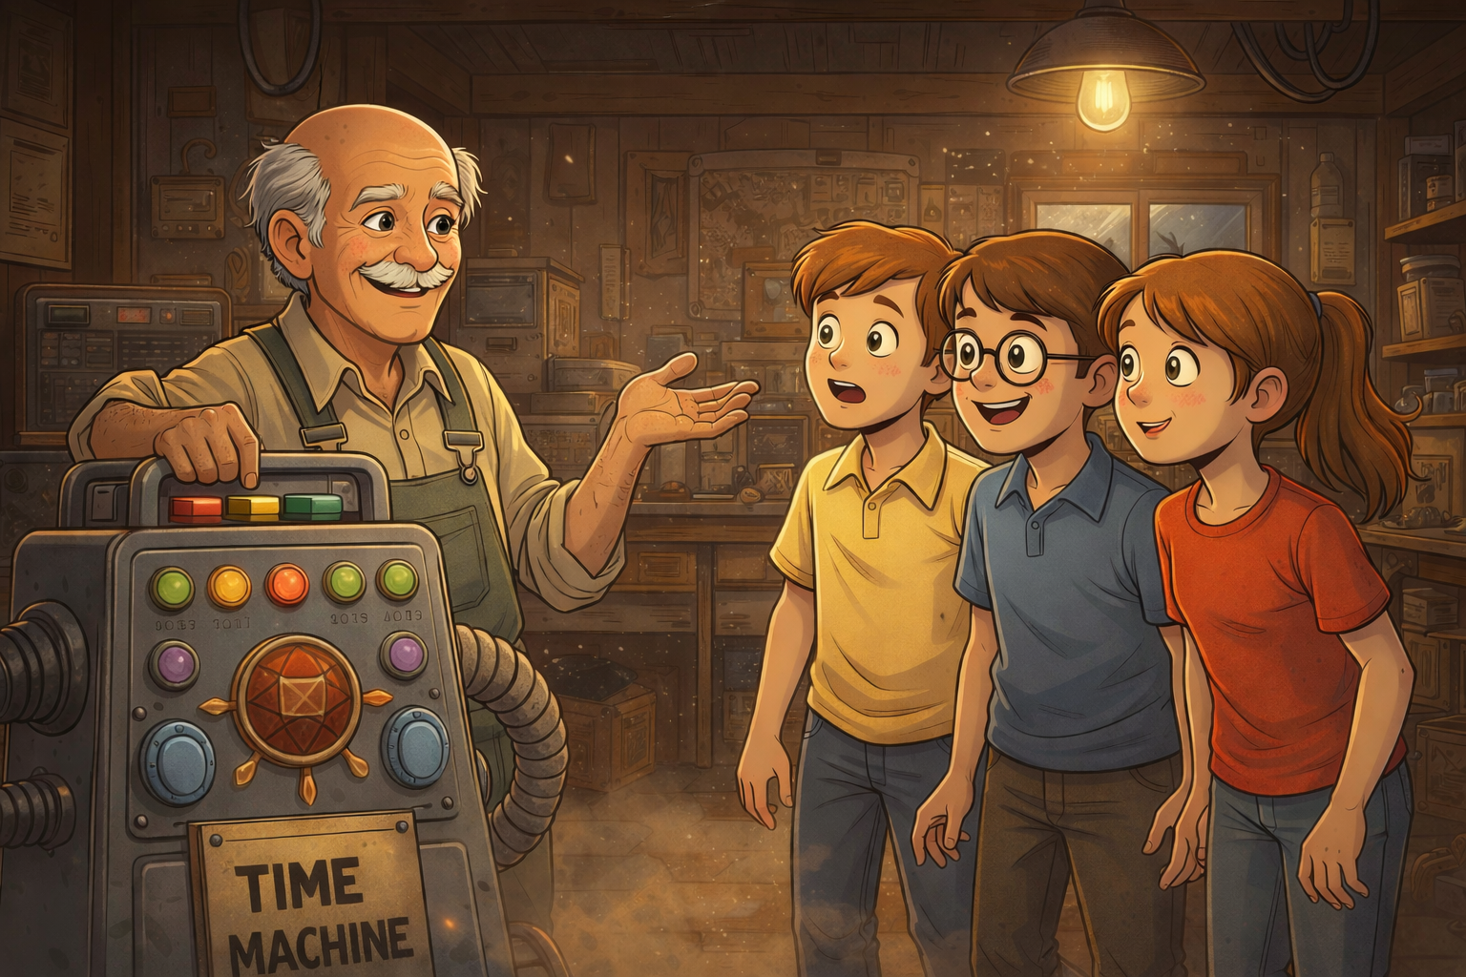

“I always wondered if that crazy contraption would actually work,” he continued with a soft chuckle. “It’s been sitting out there collecting dust for nearly twenty years, waiting for the right moment… or maybe the right people.”

He glanced toward the corner of the garage, where the machine stood quietly, as if listening.

"Wait—you KNEW it was a time machine?" Sid asked, his mouth hanging open in shock.

Grandpa’s eyes sparkled mischievously as he turned to face us. “Let’s just say…” he began slowly, lowering his voice, “…I may have been a rather adventurous inventor myself once upon a time, many years ago.”

He gave us a playful wink.

In that moment, the garage didn’t just feel like a dusty old room anymore. It felt like a place filled with secrets—unfinished ideas, hidden stories, and adventures that might not be over yet.

And suddenly, we couldn’t help but wonder what incredible journeys Grandpa had taken long before we ever pressed that green button.

Just then, a soft **beep** echoed through the garage.

We all froze.

From the corner of the room, the time machine—quiet and still just moments ago—**flickered to life**. A tiny green light blinked once… then twice… then settled into a slow, steady glow, casting a faint shimmer across the dusty walls.

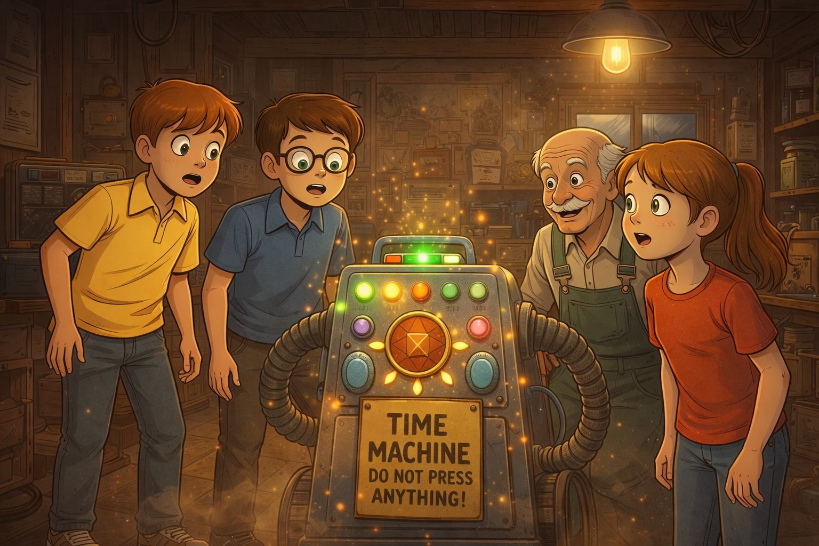

Grandpa glanced at the machine, then back at us, his smile widening just a little—as if an old memory had been gently tapped awake.

“Huh,” he murmured thoughtfully. “Well now… that’s interesting.”

We exchanged excited looks, our hearts beginning to race again. The garage felt different somehow—less like an ordinary room and more like a doorway full of secrets.

Maybe the adventure really wasn’t over after all.

But Grandpa cleared his throat and chuckled softly. “Alright, explorers,” he said, clapping his hands once. “Let’s give the future a rest for tonight. Dinner’s getting cold.”

Reluctantly, we followed him inside, glancing back one last time at the glowing machine before the garage door slowly creaked shut.

That peaceful evening, we sat together around Grandpa’s big, sturdy **oak dinner table**, still wide-eyed and buzzing with excitement from everything we had experienced. The soft golden glow from the overhead lamp wrapped the room in warmth, making it feel safe and familiar—like nothing in the world could go wrong here.

Yet our thoughts kept drifting back to the garage… and beyond.  
 Towering dinosaurs.  
 Glowing cities in the sky.  
 Flying bicycles.  
 A future we never imagined.

Every bite of food came with another memory, and every smile reminded us that the adventure hadn’t been a dream—it had really happened.

“You know what the craziest part is?” Myra took a tiny bite of bread, chewing slowly while her mind replayed the day like a movie and said thoughtfully, “We traveled millions of years into the past **and** one hundred years into the future… but Grandpa’s garage never changed at all!” She giggled.

Grandpa smiled knowingly, his eyes twinkling. “Some things are meant to stay exactly the same,” he said gently. “Like family, friendship, and good old-fashioned adventures that bring people closer together.”

We smiled at one another across the table, sharing a look only true adventurers could understand.

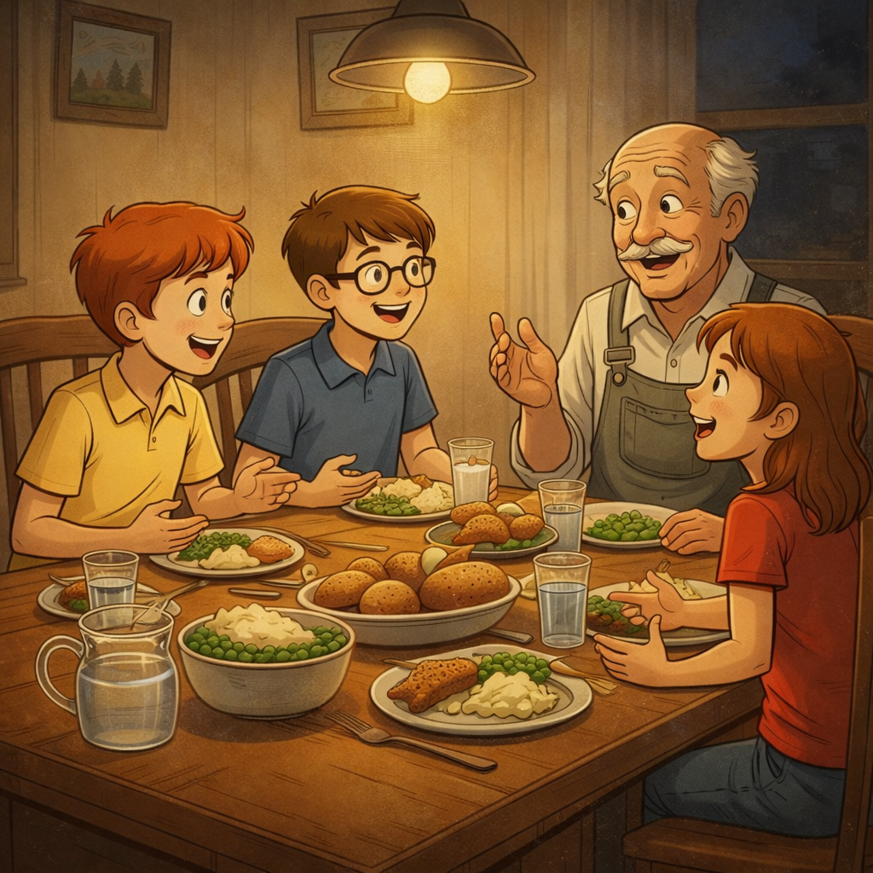

Tomorrow, we’d hide the precious time machine somewhere incredibly safe—just as we had solemnly promised Dr. Rayden.  
 Tomorrow, we’d return to our normal lives—school, homework, chores, and all the regular kid stuff.

But tonight?  
 Tonight, we were still heroes.  
 Brave explorers.  
 Time-traveling adventurers who had seen wonders beyond imagination.

And we had the most amazing, unbelievable story that absolutely nobody would ever believe—except each other, dear Grandpa, and one adorable little dinosaur named Luna.

As I looked around the familiar dinner table at the happy, comfortable faces of the people I loved most in the world, I realized something important.

The very best adventures aren’t just about the incredible places you visit or the amazing things you see.

They’re about **who you share them with**.

That night, as the house grew quiet and everyone drifted off to sleep, our hearts were still full—of laughter, courage, and memories that would stay with us forever.

And somewhere in the dark garage, hidden beneath dust and dreams of tomorrow, a tiny green light waited patiently.

**THE END**

**Moral of the Story**

True adventure isn't just about visiting exciting places or seeing amazing things—it's about the brave friends who stand by your side through every thrilling moment and scary challenge. Curiosity and wonder can lead us to incredible discoveries, but it's important to respect rules and think carefully before acting, because even the most exciting adventures can quickly become dangerous. Most importantly, the greatest treasures we find aren't ancient artifacts or futuristic technology—they're the unforgettable memories we create and the unbreakable bonds of friendship and family that make every journey worthwhile.